**IT301 : Parallel Computing Lab**

**NAME: BHUVANESWAR**

**ROLL NO: 191IT107**

**MPI Programming**

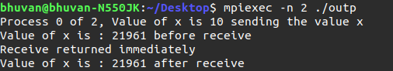**1A)**

**1B)**

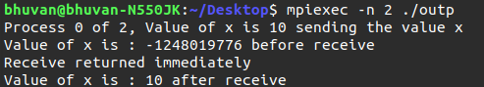

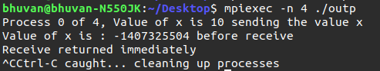**1C)**

**2)**



**Observation: Bcast() function broadcasts data in root process to all other processes.**

**3)**



**Observation: Reduce() function recues the datta from all processes acoording to the operation. Since operator here is sum and data in each process is rank the final value after computing is 6.**

**4)**

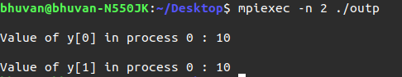

**Observation: MPI_Gather() collectrs data from all the proccesses and stores it in the guven buffer at the specified process.**

**5)**

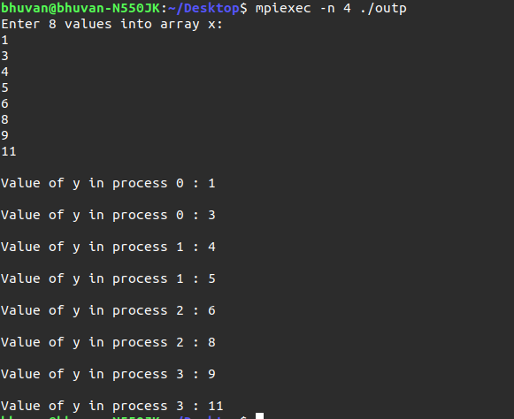

**6)**

